**COMSATS University Islamabad,   
Park Road, Chak Shahzad, Islamabad Pakistan**

SOFTWARE DESIGN DESCRIPTION   
(SDD DOCUMENT)

for

**ShopInsight**  
Version 1.0

***By***

**Asim Nadeem CIIT/SP17-BCS-069/ISB**

**Awais Tariq CIIT/SP17-BCS-084/ISB**

***Supervisor***  
**Mr. Zaheer-ul-Hussain Sani**

***Bachelor of Science in Computer Science (2017-2021)***

**Table of Contents**

**Introduction** **1**

**Design methodology and software process model** **1**

**System overview** **2**

Architectural design 2

Process flow/Representation 3

3.2.1 Activity Diagrams: 3

3.2.1.1 Admin Portal Activity: 3

3.2.1.2 Admin Set up Scraper Activity 5

3.2.1.3 User Homepage Activity: 6

3.2.1.4 User Search and Filtering Activity 7

3.2.1.5 User View Listing Details Activity 8

3.2.1.5 User Manage Preferences Activity 9

3.2.1.6 Business Partner Portal Activity 10

**Design models** **11**

Class Diagram 11

Sequence Diagram 12

**Data design** **16**

Data dictionary 16

**Algorithm & Implementation** **18**

Scraper 18

Data Cleaning and Parsing 18

Filtering offer listings 18

Recommending offer listings 19

View nearest store 19

**Software requirements traceability matrix** **19**

**Human interface design** **23**

Screen images 23

**Appendix I** **32**

**Revision History**

|  |  |  |  |
| --- | --- | --- | --- |
| **Name** | **Date** | **Reason for changes** | **Version** |
|  |  |  |  |
|  |  |  |  |

**Application Evaluation History**

|  |  |
| --- | --- |
| **Comments (by committee)**  **\*include the ones given at scope time both in doc and presentation** | **Action Taken** |
|  |  |
|  |  |

**Supervised by**

**<Supervisor’s Name>**

Signature______________

# Introduction

The craze of shopping is at its peak among the consumers, nowadays. It is now considered a status symbol to be able to shop for the latest fashion trends. Over the recent years, a number of designer brands have emerged that have spearheaded the growth of the fashion industry in our country. However, the exclusive fashion articles introduced by these brands are quite excessively priced for an average consumer. In addition to clothing and fashion accessories, the trend of dining out at restaurants is also on the rise in our country. More and more eateries are popping up in the developed cities; each trying to offer a better fine-dining experience than the other, albeit at an extravagant price.

Hence, it is not possible for an average consumer to always get their hands on the latest and trending products for bragging rights. For this reason, a large majority of the people are always looking forward to sales, promotions, and discount offers from their favorite designer brands and eateries to get their hands on the latest fashion trends at a price that they can afford. However, most of the time the promotions are not properly targeted towards these consumers due to which they miss out on these discount offers and sales.

The product we will be developing is a web and mobile-based information system which will provide a unified platform for consumers to stay up-to-date on the latest sales and promotions offered by the businesses and products that they are interested in. The system will be easily accessible from any mobile or desktop device that has an internet connection. Additionally, users can choose to be notified by alerting mechanisms about the promotions related to the brands, products, or categories they subscribe to.

The proposed system will also enable businesses and brands to target consumers based on their interests and geographical presence. This combination of targeting attributes is very difficult to attain from conventional advertising methods, which include television advertisements, billboard advertisements, and social media targeting. Thus, the proposed system will also solve the problem of advertising, targeting and reaching the right consumers, by providing a unified advertising platform that will greatly aid businesses to grow. Our service will enable businesses to focus on their product while their marketing and advertising is handled by our system.

# Design methodology and software process model

* 1. **Software Process Methodology**

We will adopt **Design Thinking** methodology for our system development. Design Thinking is an iterative process in which we seek to understand the user, challenge assumptions, and redefine problems in an attempt to identify alternative strategies and solutions that might not be instantly apparent with our initial level of understanding. At the same time, Design thinking provides a solution-based approach to solving problems. It is a way of thinking and working as well as a collection of hands-on methods.

* 1. **Software Design Methodology**

we will be using the Object-Oriented approach and methodology, which will enable us to divide tasks and functions easily to make the code easier to implement, understand and debug.

# System overview

Shop Insight contains three user’s interaction with the system i.e. **Super Admin** which is able to add/remove/edit businesses and handle consumer queries, **Businesses/Shops** which are able to post new sales/discounts on their brands, **Consumers** which pin shops/businesses/brands according to their interests in order to get notification whenever there is some new sales on an item.

## Architectural design

**Shop Insight** system is based on heavy user interaction so we will use MVC design patterns at application level. Client architecture will have MVC (Model-View-Controller) pattern which will communicate with the server. Clients (IOS/Android/Web) will basically send requests to the server in order to read and write data from db. Server will retrieve and send data to the database (Amazon DynamoDb) through the Rest API. Following diagram shows the architectural design of the “Shop Insight” used to identify the interaction of components of the system.

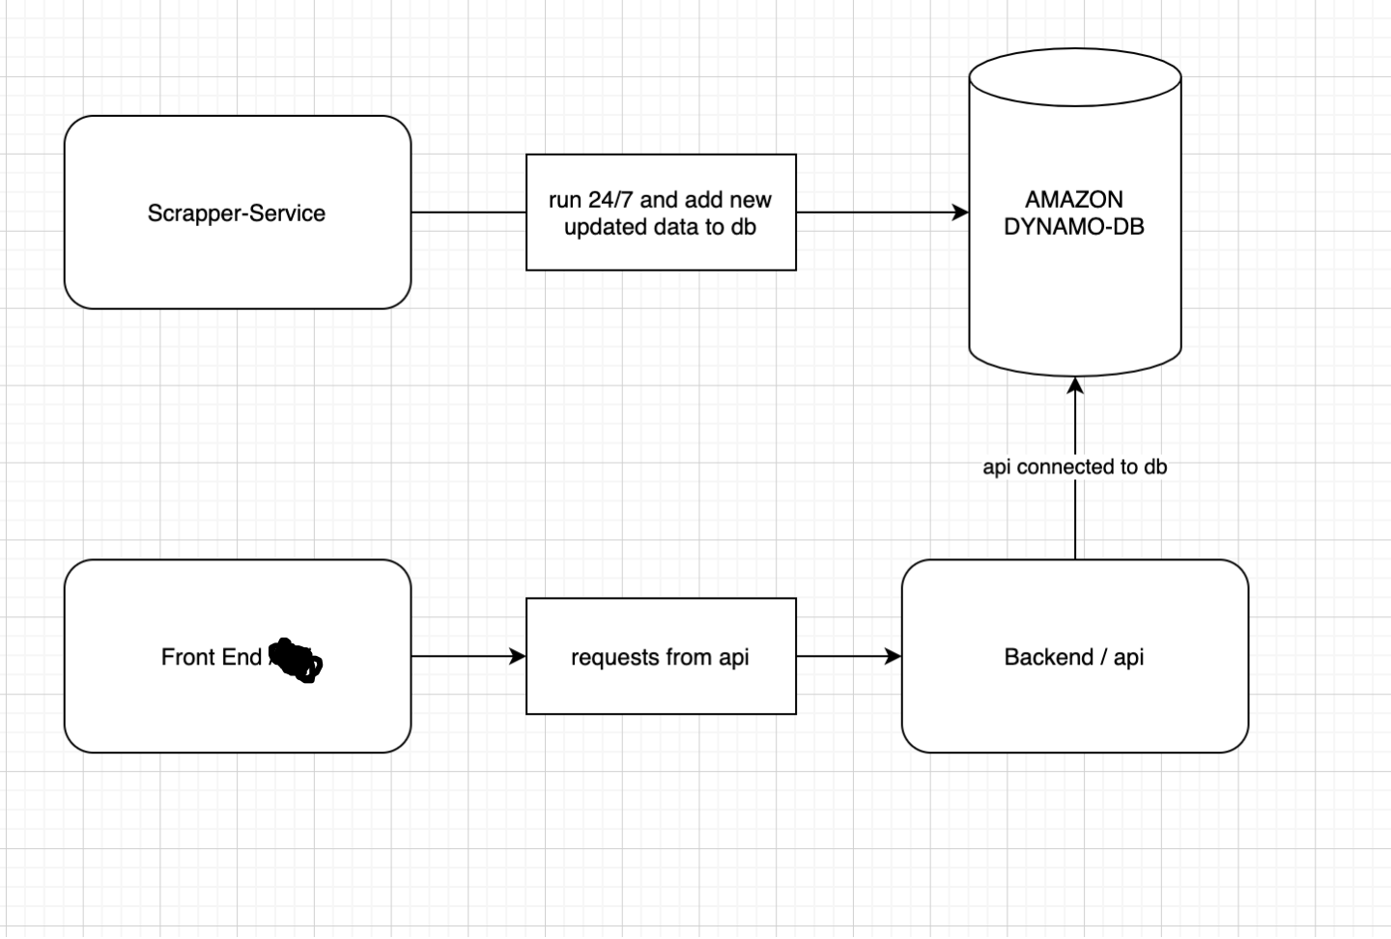

## Process flow/Representation

### 3.2.1 Activity Diagrams:

This section represents the major process flow of the system. The following are the Process Flow Activity diagrams for the Shop Insight.

#### 3.2.1.1 Admin Portal Activity:

The following diagram shows the main process flow of the Admin console. Super Admin can add new admins (staff members). Admins can manage business pages, which includes creating, and updating business pages, adding stores for business pages, adding a business partner as admin of a business page. The major function of the admin is to set up scrapers for business pages, and approve / clean up the scraped offer listings from the business pages, which are also mentioned in the following activity diagram.

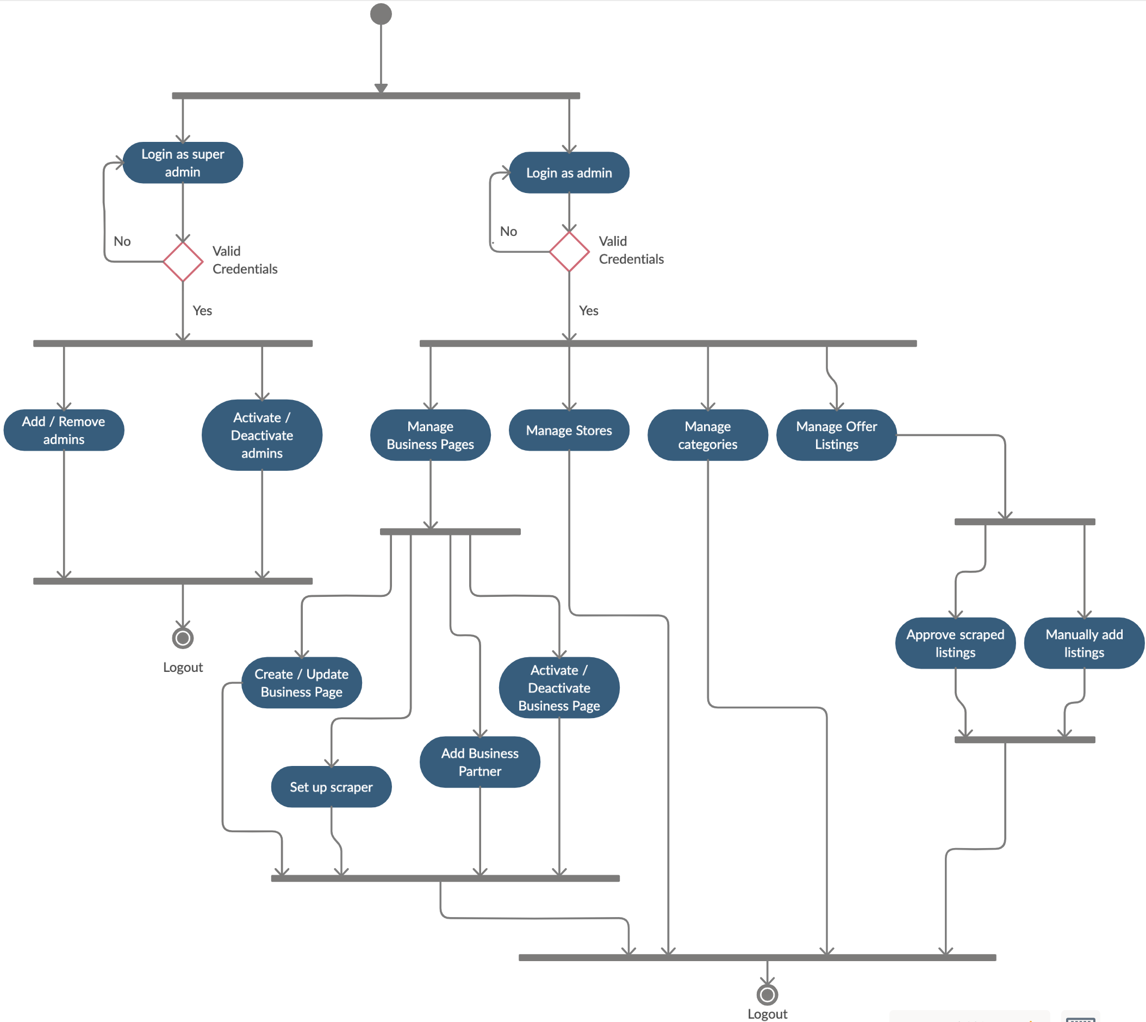

#### 

#### 3.2.1.2 Admin Set up Scraper Activity

The following diagram shows the process flow of a user when he visits homepage and performs search or filtering of offer listings according to his preference. It includes multiple filters such as that of location, discount value, categories and other deals. The activity diagram showing the process of filtering offer listings is as follows.

#### 

#### 3.2.1.3 User Homepage Activity:

The following diagram shows the main process flow of a user when he visits homepage. Some important activities on the homepage for the user include viewing featured listings, recommended listings, viewing nearby listings and viewing listing details, which are mentioned in the following activity diagram

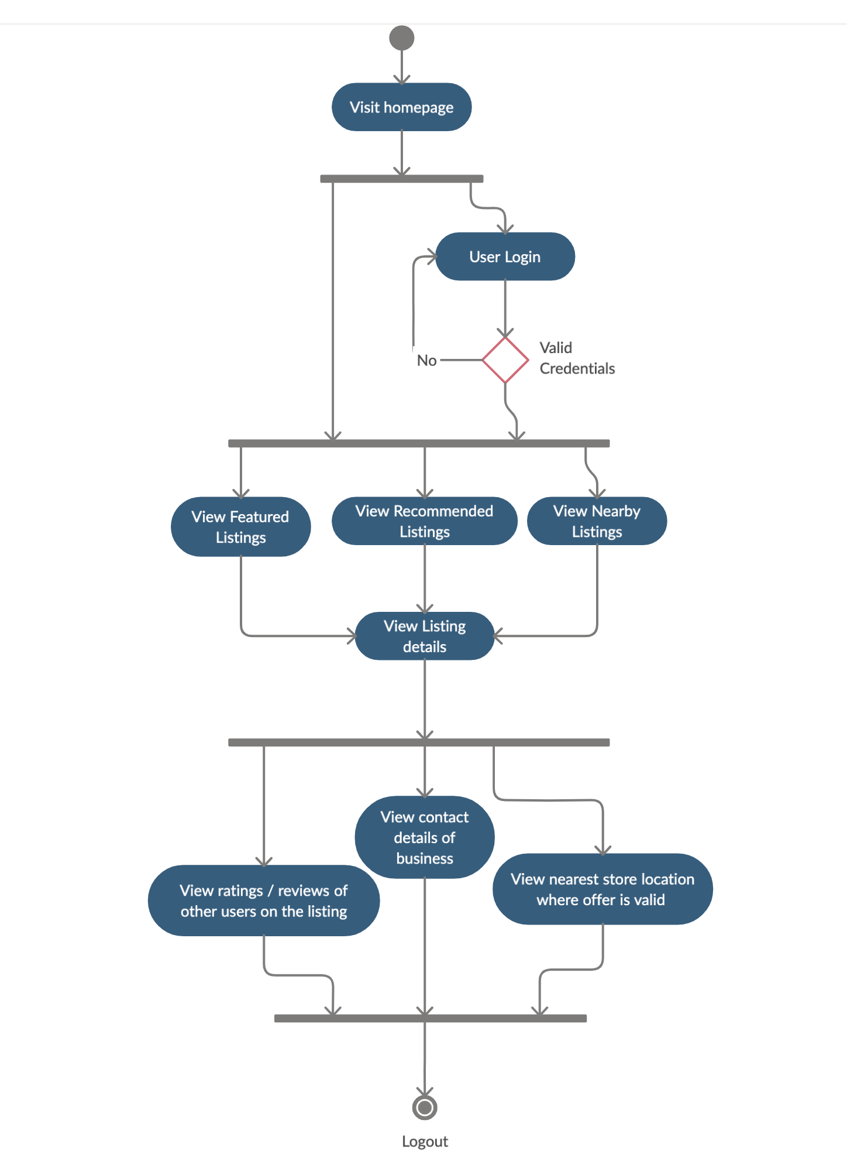

#### 3.2.1.4 User Search and Filtering Activity

The following diagram shows the process flow of a user when he visits homepage and performs search or filtering of offer listings according to his preference. It includes multiple filters such as that of location, discount value, categories and other deals. The activity diagram showing the process of filtering offer listings is as follows.

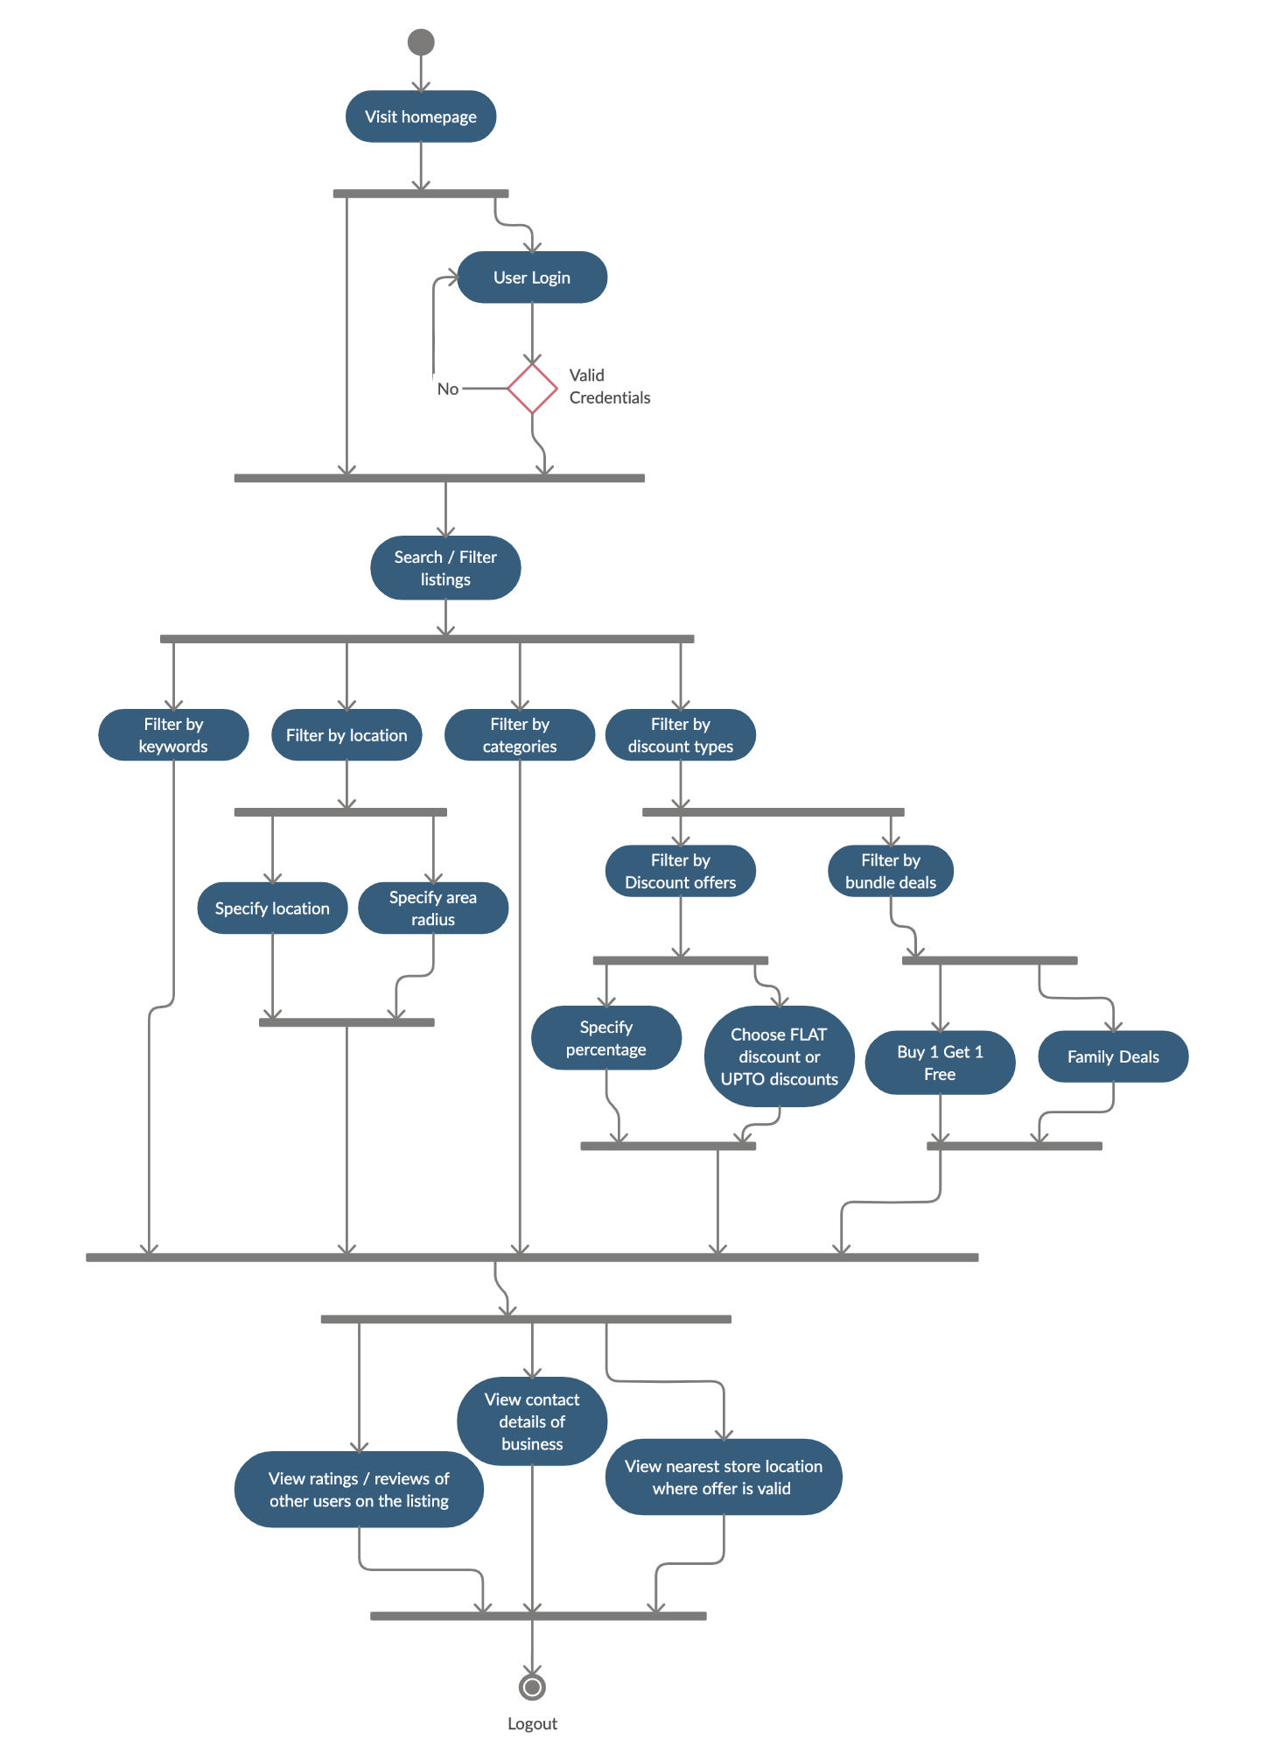

#### 3.2.1.5 User View Listing Details Activity

The following diagram shows the process flow of a user when he opens the detailed view page for an offer listing.

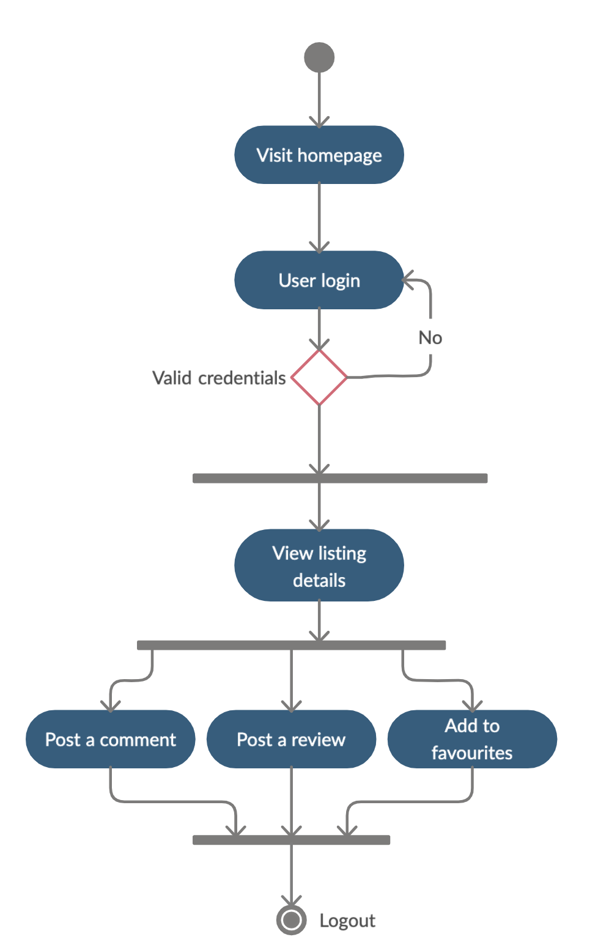

#### 3.2.1.5 User Manage Preferences Activity

The following diagram shows the process flow of a user when he visits his profile preferences page after logging in.

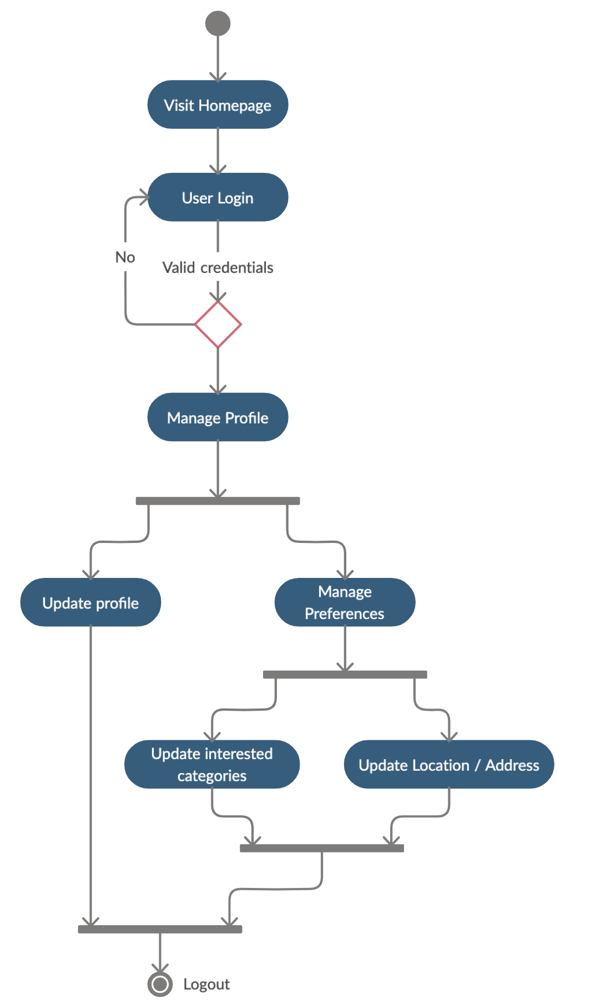

#### 3.2.1.6 Business Partner Portal Activity

The following diagram shows the process flow of a user when he visits his profile preferences page after logging in.

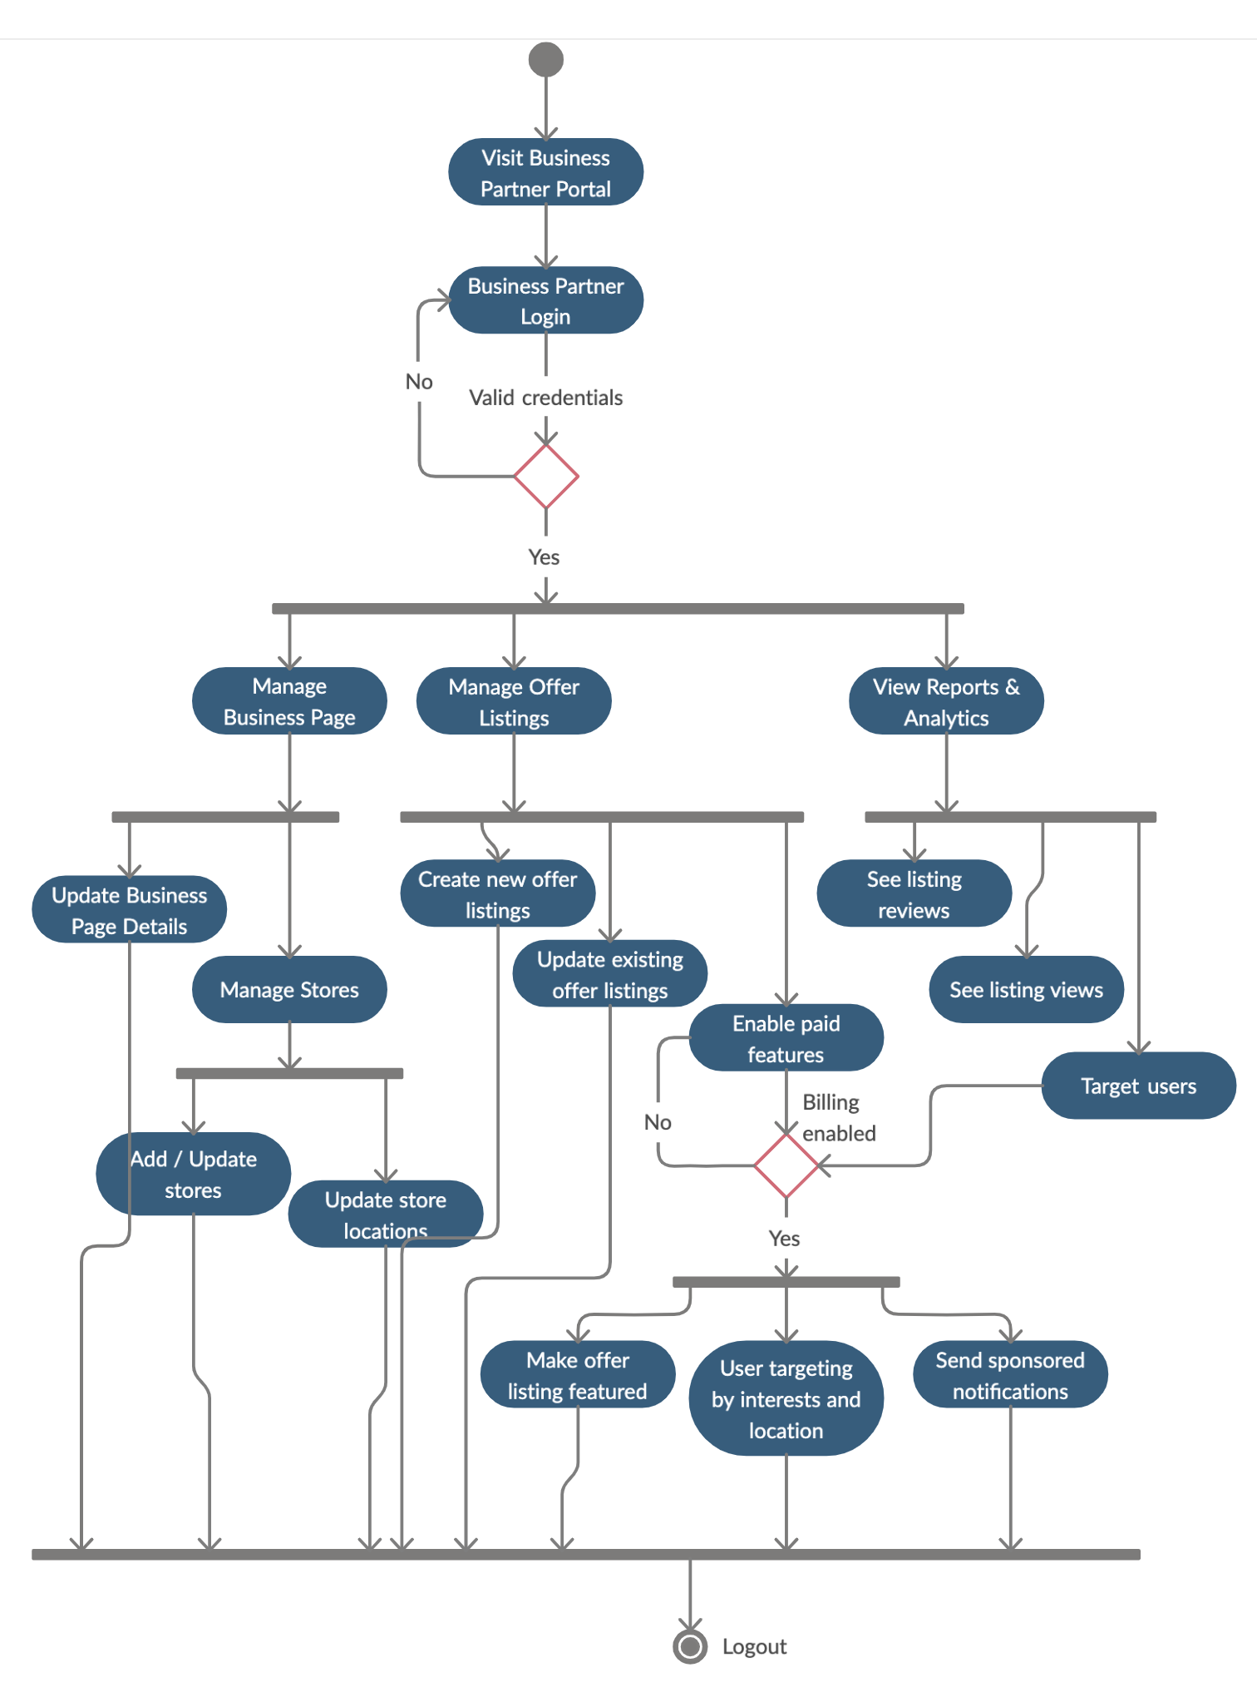

# Design models

**Below is the design models for the system;**

## Class Diagram

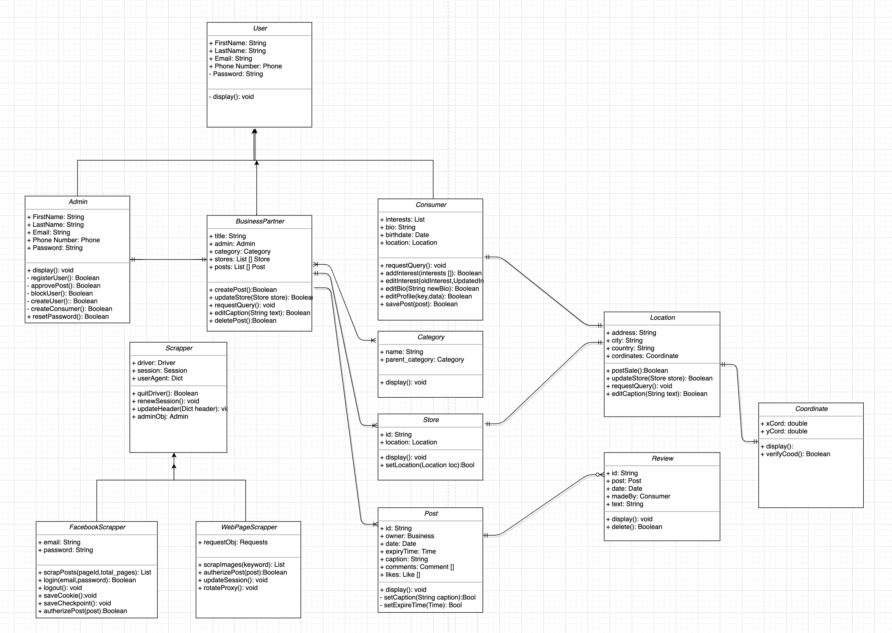

## 

## Sequence Diagram

The Following are the Sequence diagrams for the Shop Insight.

* + 1. **Consumer Search Sequence**

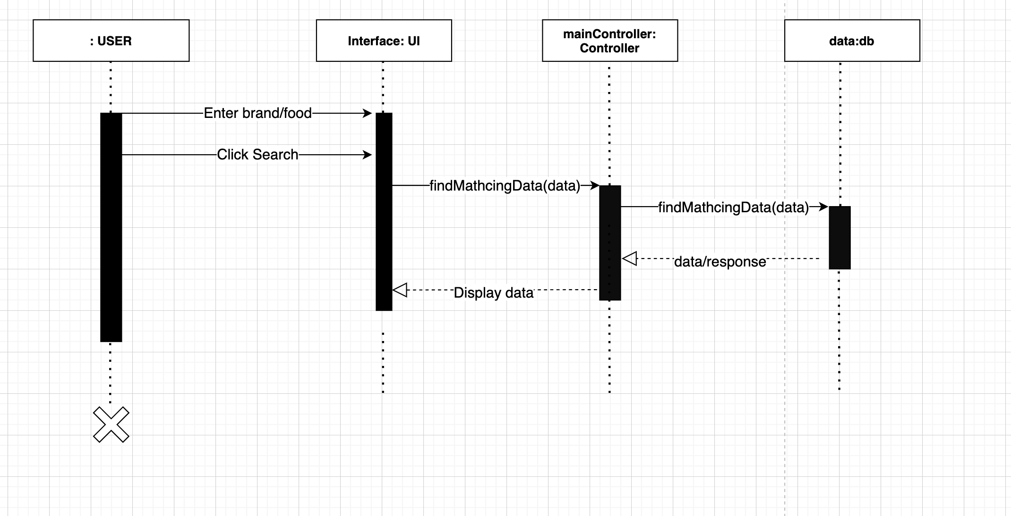

* + 1. **Scrapp Posts**

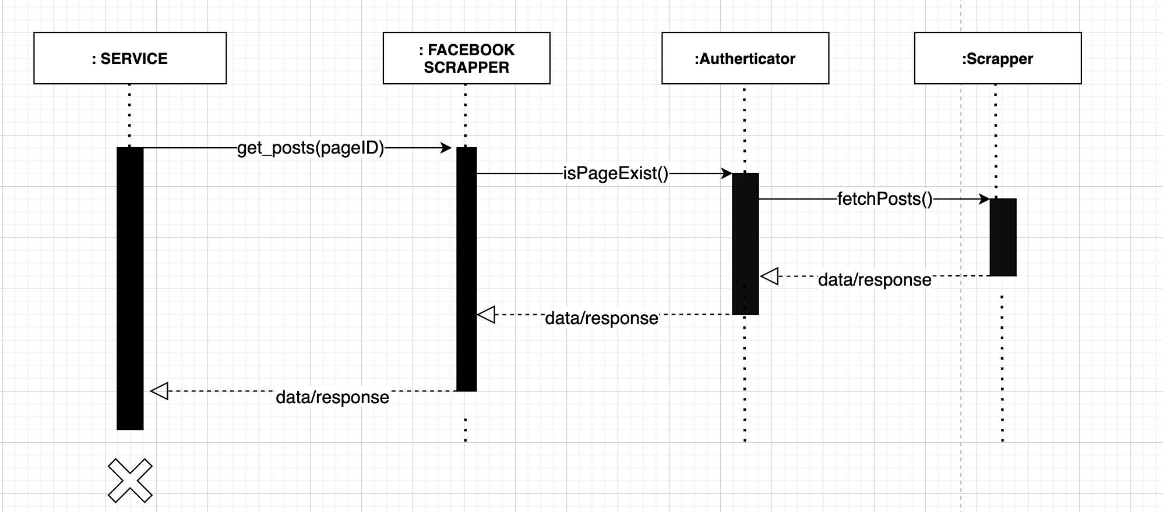

* + 1. **User Mark Interested To Some Brand**

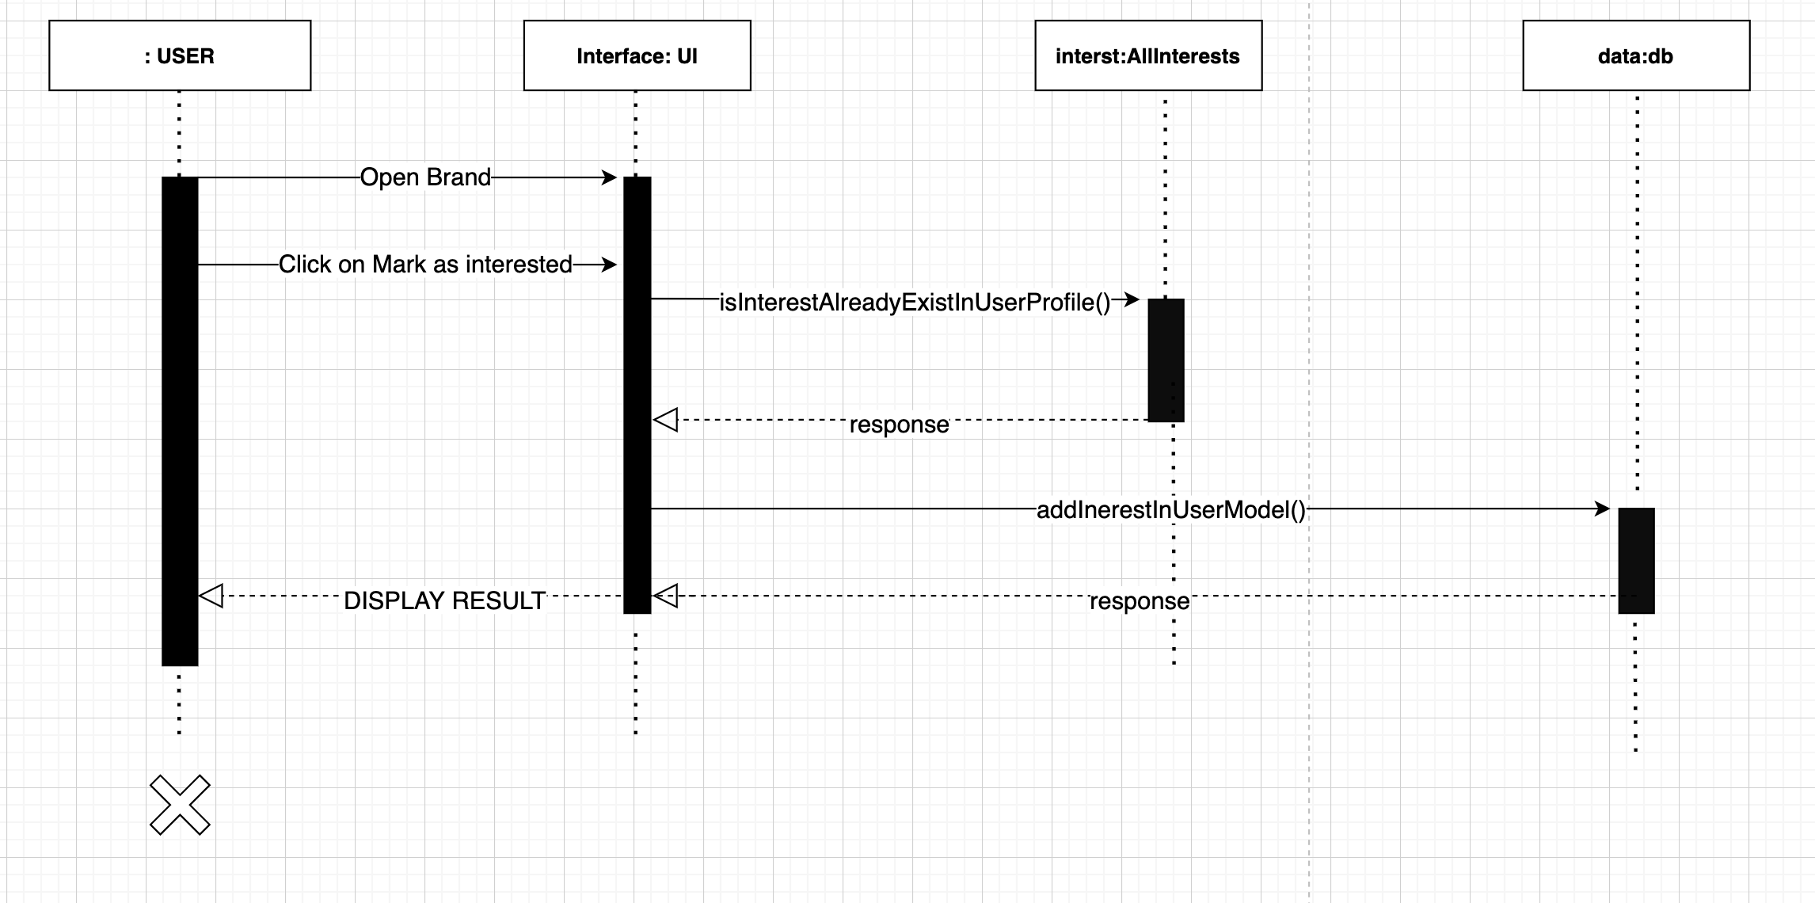

* + 1. **Scrapper Scheduler Service**

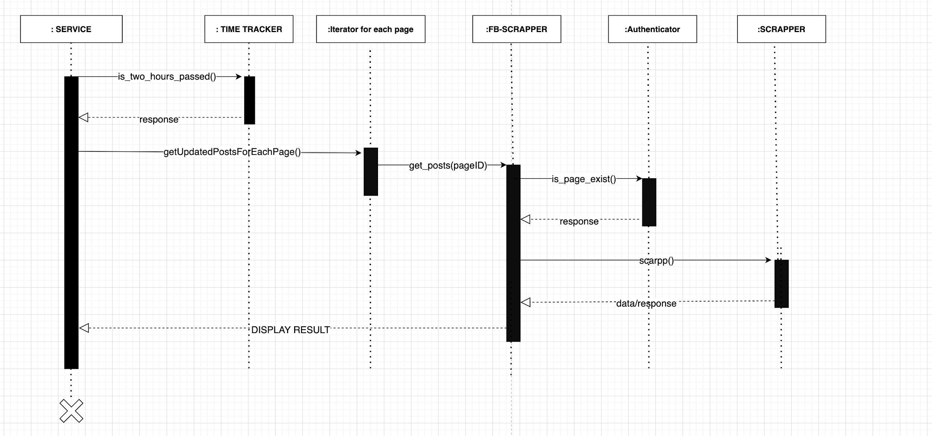

* + 1. **Add new Page for Facebook**

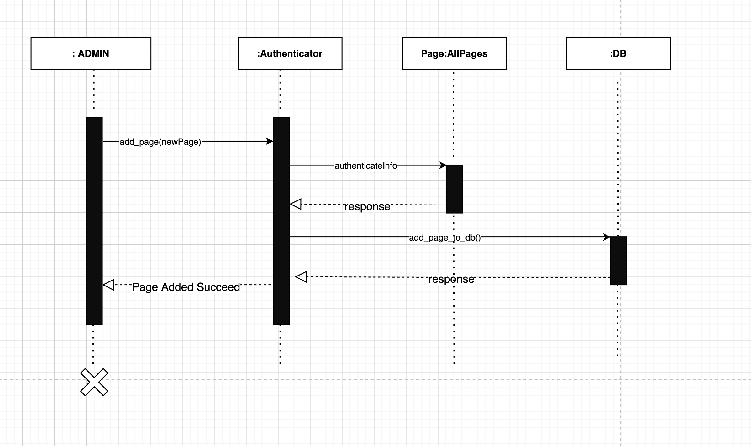

* + 1. **Sign Up Sequence Diagram**

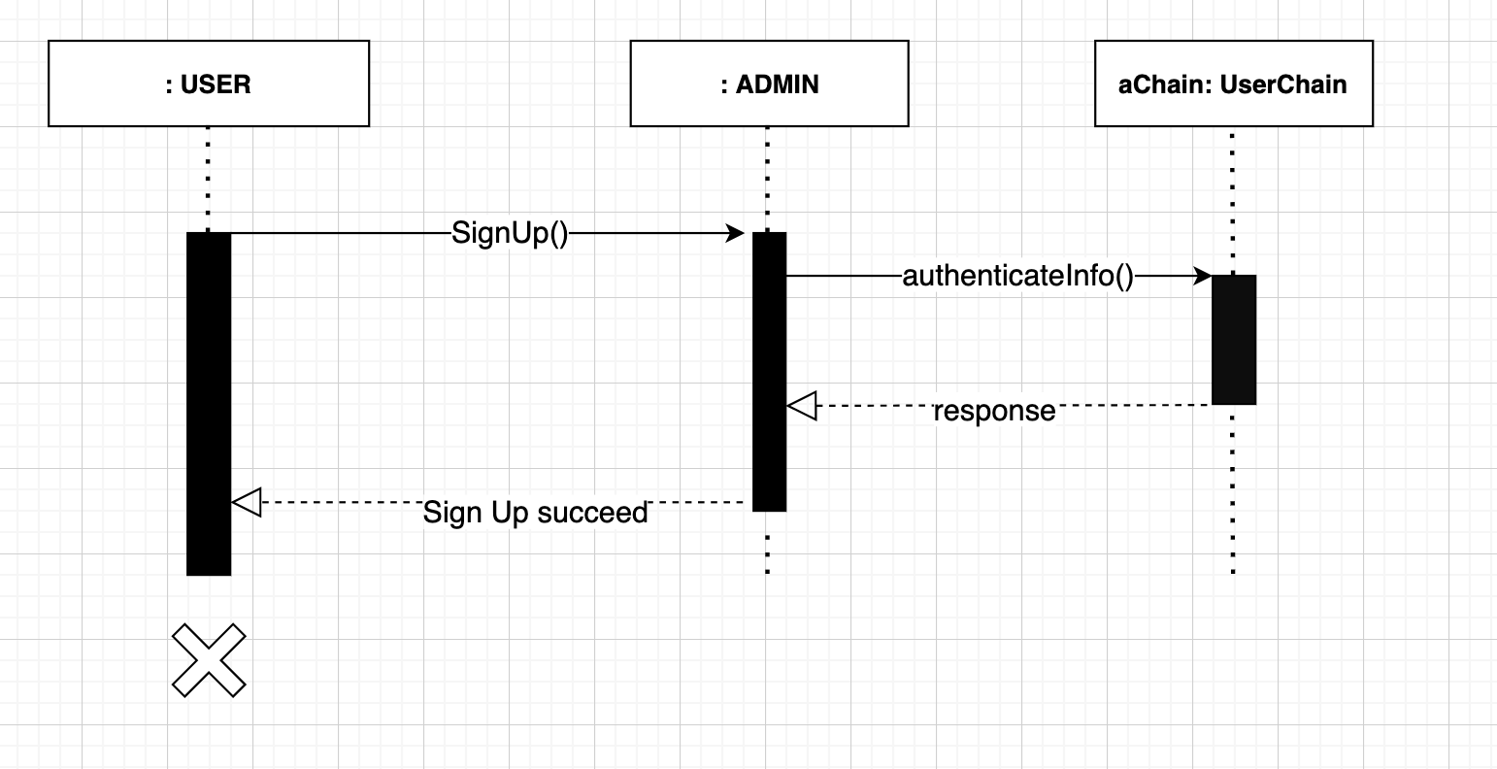

* + 1. **Login In Sequence Diagram**

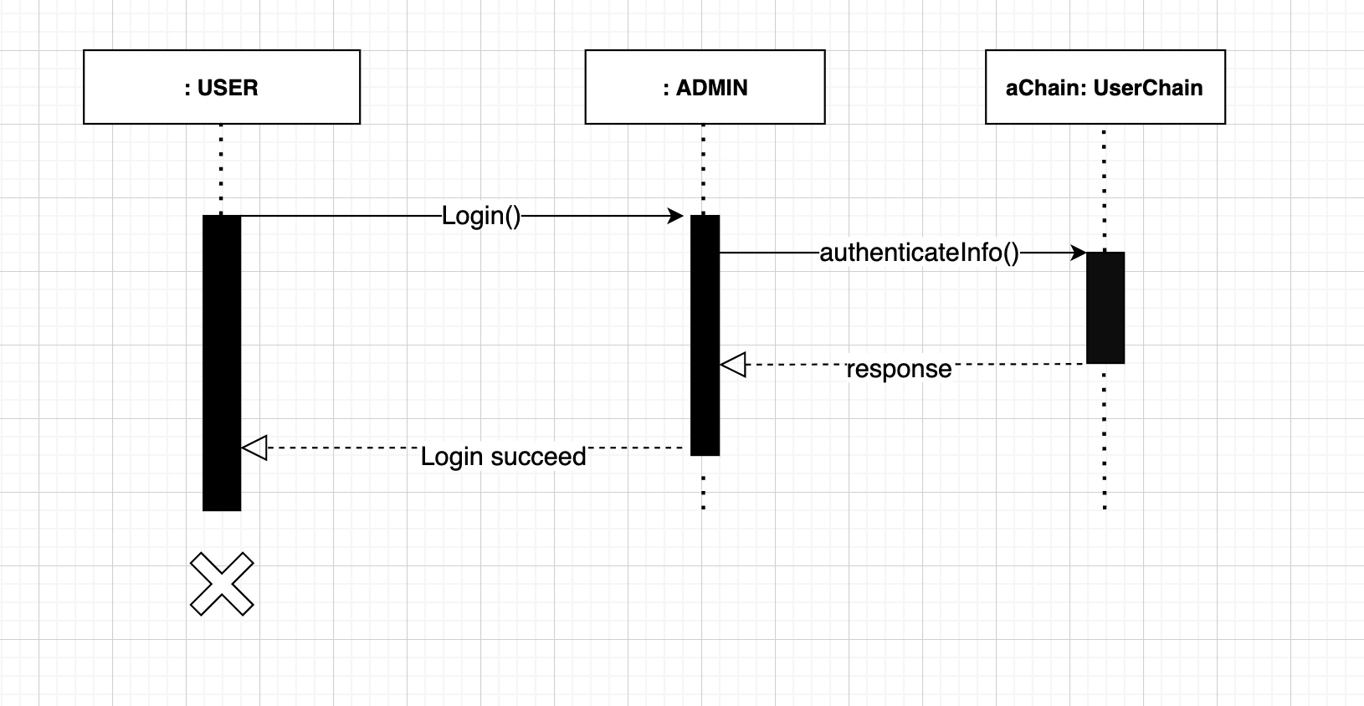

* + 1. **Create Post Sequence**

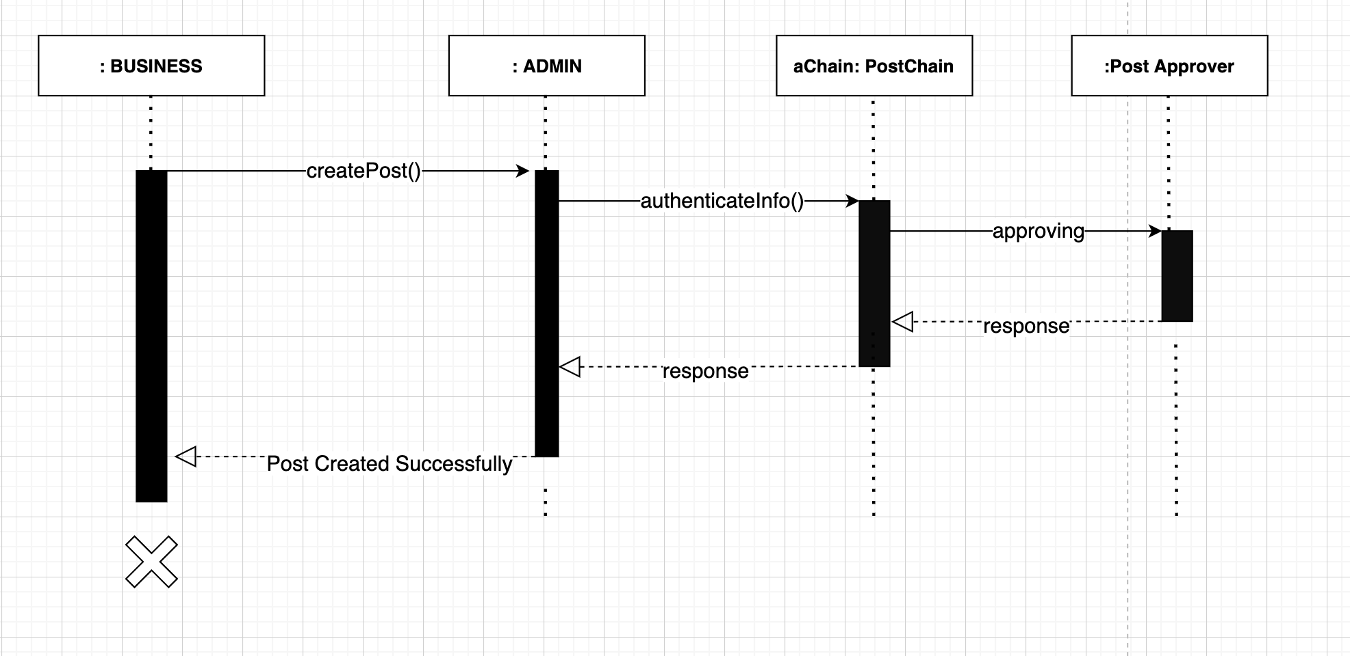

# Data design

We use a relational approach to design and model our database objects. Each object / class has well-defined attributes and relations beforehand.

## Data dictionary

|  |  |  |  |
| --- | --- | --- | --- |
| **Table** | **Attribute** | **Type** | **Description** |
| User | email | CharField | E-mail address of user |
| User | first_name | CharField | First name of user |
| User | last_name | CharField | Last name of user |
| User | password | CharField | Password of user |
| Profile | bio | TextField | Bio of a user |
| Profile | birth_date | DateField | Date of Birth of a User |
| Profile | favorites | Business (M2M) | Business pages that the user has favorited. |
| Profile | interests | Category (M2M) | Categories that the user is interested in. |
| Profile | lkl | CoordinatesField | User’s last known location |
| Profile | location | Location (One-to-one) | Location / address of the user |
| Profile | phone_number | PhoneNumberField | Phone number of the user |
| BusinessPage | admin | User (One-to-one) | The user administering the business page. |
| BusinessPage | title | CharField | Title / name of the business. |
| BusinessPage | categories | Category (M2M) | The categories of business page. |
| Store | location | Location (One-to-one) | The location of the store. |
| Store | parent_business | BusinessPage (FK) | The parent business of the store. |
| Category | name | CharField | The name of a category. |
| Category | parent_category | Category (FK) | The parent category of the category if the category is a subcategory. |
| OfferListing | business | Business (FK) | The business offering the deal / discount. |
| OfferListing | details | TextField | The details and terms pertaining to the offer. |
| OfferListing | end_date | DateField | The date till when offer is valid. |
| OfferListing | sale_type | CharField | The type of sale (Discount or Bundle Deal) |
| OfferListing | sale_value | IntegerField | The value of sale. (70%, 30%, etc.) |
| OfferListing | title | CharField | The title of the offer. |
| OfferListing | type | CharField | The type of sale (FLAT, UPTO, or BUY 1 GET 1 FREE, etc.) |
| Scraper | business | Business (FK) | The business the scraper is set up for. |
| Scraper | type | CharField | The type of scraper. Either FACEBOOK or WEBPAGE. |
| Scraper | webpage_url | CharField | The webpage from where to scrape results. (Applicable if type is WEBPAGE) |
| Scraper | facebook_page_id | CharField | The facebook page ID from where to scrape results. (Applicable if type is FACEBOOK) |
| Scraper | section_selector | CharField | The selector of the section from where to scrape results from. |
| Scraper | logs | TextField | The logs from the last run of scraper |
| Scraper | sched_time | CharField | The time to run the scraper in CRON format. (? ? ? ? ?) |

# Algorithm & Implementation

## Scraper

Scraping offers from various sources is a core part of our system. The scrapers are actually database objects which can be created by admin. Admin can add two types of scrapers, these include:

* **Facebook page scraper:** While adding a facebook scraper, the admin must provide a Facebook Page ID from where to get posts.
* **Business webpage scraper:** While adding a webpage scraper, the first step is for admin to enter a webpage URL, and click next. After clicking next, the admin will be shown the specified webpage embedded in the form, where he can highlight and select various sections of the webpage. The admin can click on any section of the webpage, and the selector of that section will be generated. Thus, two items will be extracted from this process, the webpage URL, and the selector of the section selected by admin where the promotions usually appear.

After the admin has created a scraper, he can schedule the scraper using a user-friendly input form.

The scrapers will be run periodically according to the scheduling settings chosen by the user and extract the data in a raw form.

## Data Cleaning and Parsing

Data cleaning is another core part of our software implementation. In this part, we parse the raw posts / listings that are scraped by our scrapers. We employ multiple techniques in this process, such as regular expression matching for extracting dates of the offer, checking existence of various keywords to classify the post as a discount offer or not, etc.

## Filtering offer listings

Another core part of our software implementation is to allow the user to filter the offer listings based on multiple criteria. This includes:

* Location-based filtering (*In 10KM radius of my location*)
* Category-based filtering (*Desi food*, *Men’s clothing*)
* Filtering based on discount types and deals (*At least up to 50% off*, *At least flat 30% off, Buy 1 get 1 free deals*)
* Additionally, we also give the user an option to use a combination of these filters

## Recommending offer listings

We also implement a recommendation algorithm, to recommend offers for a user which takes into account: i) User’s location ii) User’s interested categories iii) User’s favorited business

Additionally, as the user browses different listings, we also take into account the user’s viewing patterns.

## View nearest store

When a user is viewing an offer listing, he is also shown an action button to view the nearest store location where the offer can be availed. For this, the business page must have valid store locations entered near the user.

# Software requirements traceability matrix

This section should contain a table that summarises how each software requirement has been met in this document. The tabular format permits one-to-one and one-to-many relationships to be shown.

**Table 1 Requirements Traceability Matrix**

|  |  |  |  |
| --- | --- | --- | --- |
| **Req. Number** | **Ref. Item** | **Design Component** | **Component Items** |
| 1 | UC-1.1: Create a user account | Sequence Diagram  Class Diagram | User Signup Sequence  Consumer Class |
| 2 | UC-1.2: Login to user account | Activity Diagram  Sequence Diagram  Class Diagram | User Homepage Activity  User Login sequence  Consumer Class |
| 3 | UC-1.3: Set up user preferences | Activity Diagram  Class Diagram | User Manage Preferences Activity  Consumer Class |
| 4 | UC-1.4: Update user preferences | Activity Diagram  Class Diagram | User Manage Preferences Activity  Consumer Class |
| 5 | UC-1.5: Update user profile | Activity Diagram  Class Diagram | User Manage Preferences Activity  User Class |
|  |  |  |  |
| 6 | UC-1.6: Update user password | Activity Diagram  Class Diagram | User Manage Preferences  Activity  User Class |
| 7 | UC-1.7: Recover user password | Activity Diagram  Class Diagram | User Login Activity  User Class |
| 8 | UC-1.8: View featured listings | Activity Diagram  Class Diagram | User Homepage Activity  Post Class |
| 9 | UC-1.9: View personalized listings | Activity Diagram  Class Diagram | User Homepage Activity  Consumer Class  Post Class |
| 10 | UC-1.10: Filter listings by parameters | Activity Diagram  Sequence Diagram | User Search and Filtering Activity  Consumer Search Sequence |
| 11 | UC-1.11: Post a comment on listing | Activity Diagram | User View Listing Details Activity |
| 12 | UC-1.12: Post a review on listing | Activity Diagram | User View Listing Details Activity |
| 13 | UC-1.13: Add listing to favorites | Activity Diagram | User View Listing Details Activity |
| 14 | UC-1.14: View favorite listings | Activity Diagram | User View Listing Details Activity |
| 15 | UC-1.15: Create business partner account | Activity Diagram  Class Diagram | Business Partner Portal Activity  BusinessPartner Class |
| 16 | UC-1.16: Login to business partner account | Activity Diagram  Class Diagram | Business Partner Portal Activity  BusinessPartner Class |
| 18 | UC-1.18: Manage My Business | Activity Diagram  Class Diagram | Business Partner Portal Activity  Admin Portal Activity  Business Class |
| 19 | UC-1.19: Manage business outlets | Activity Diagram  Class Diagram | Business Partner Portal Activity  Admin Portal Activity  Store Class  Business Class |
| 20 | UC-1.20: Add a listing | Activity Diagram  Class Diagram | Business Partner Portal Activity  Admin Portal Activity  Post Class |
| 21 | UC-1.21: Manage Listings | Activity Diagram  Class Diagram | Business Partner Portal Activity  Admin Portal Activity  Post Class |
| 22 | UC-1.22: View prospective customers | Activity Diagram  Class Diagram | Business Partner Portal Activity  Consumer Class |
| 23 | UC-1.23: Toggle a listing featured | Activity Diagram  Class Diagram | Business Partner Portal Activity  Post Class |
| 24 | UC-1.24: Target advertisements | Activity Diagram | Business Partner Portal Activity |
| 25 | UC-1.25: View consumer analytics | Activity Diagram  Class Diagram | Business Partner Portal Activity  Consumer Class  BusinessPartner Class |
| 26 | UC-1.26: Admin Login | Activity Diagram  Class Diagram | Admin Portal Activity  Admin Class |
| 27 | UC-1.27: Set up scraper | Activity Diagram  Class Diagram | Admin Set up Scraper Activity  Admin Class  Scraper Class |
| 28 | UC-1.28: Start a scraper | Activity Diagram  Class Diagram | Admin Set up Scraper Activity  Admin Class  Scraper Class |
| 29 | UC-1.29: Scheduling a scraper | Activity Diagram  Class Diagram | Admin Set up Scraper Activity  Admin Class  Scraper Class |
| 30 | UC-1.30: View scraper logs | Activity Diagram  Class Diagram | Admin Set up Scraper Activity  Admin Class  Scraper Class |
| 31 | UC-1.31: Manage a scraper | Activity Diagram  Class Diagram | Admin Portal Activity  Scraper Class |

# 

# Human interface design

The system is designed while keeping user experience and user-friendliness of the system as a priority.

## Screen images

The following are the screen images of the ShopInsight mobile application.

## 

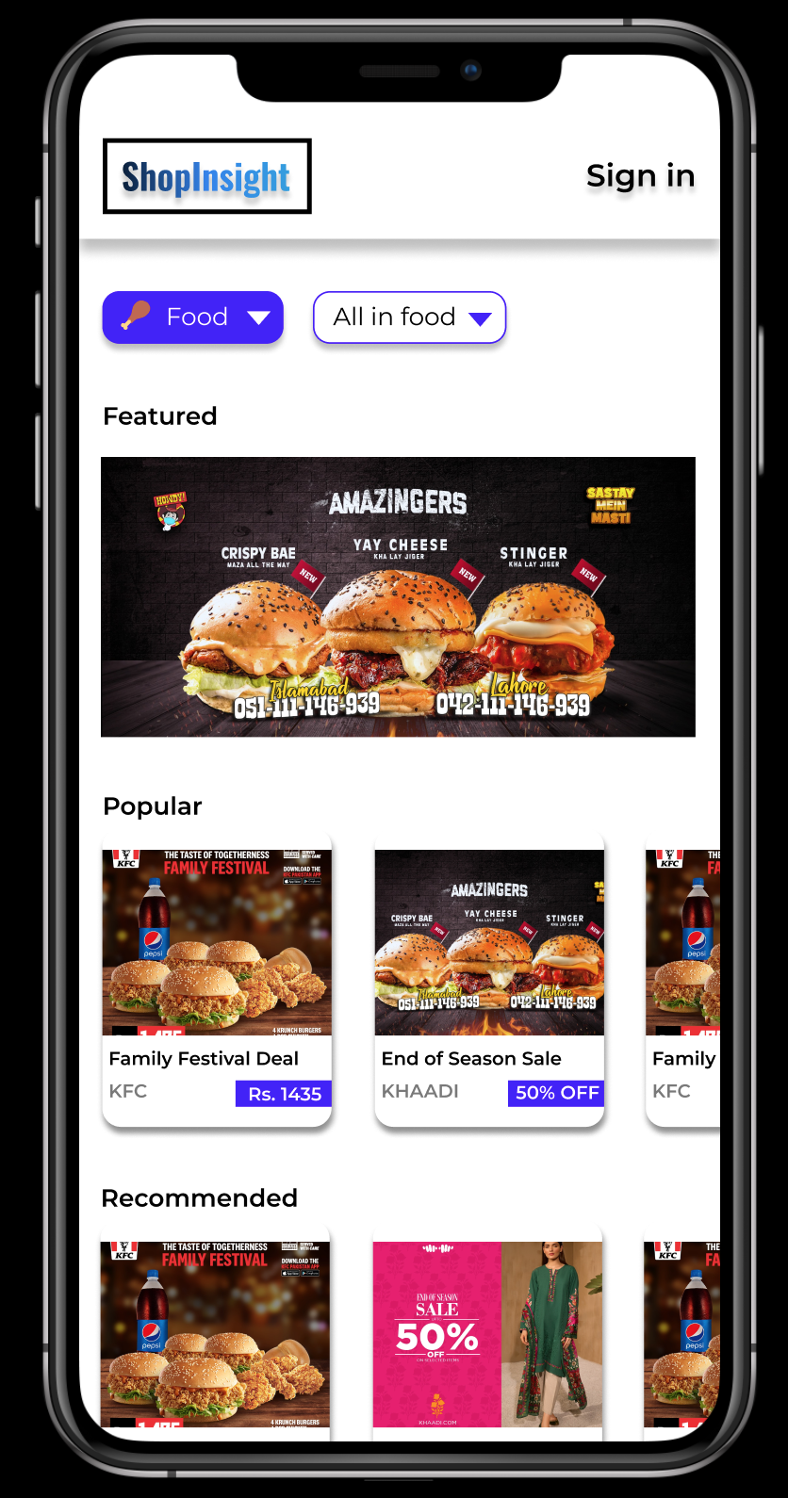

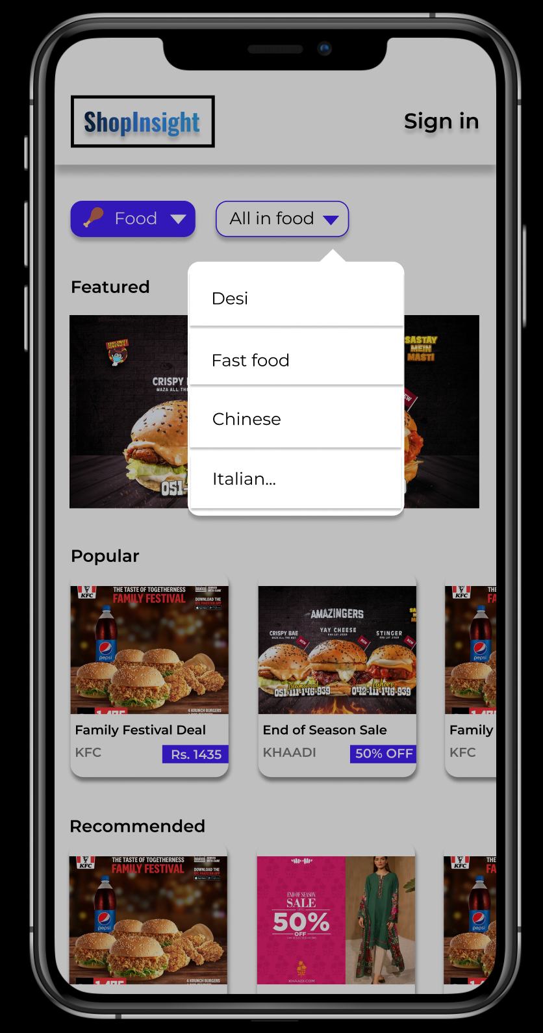

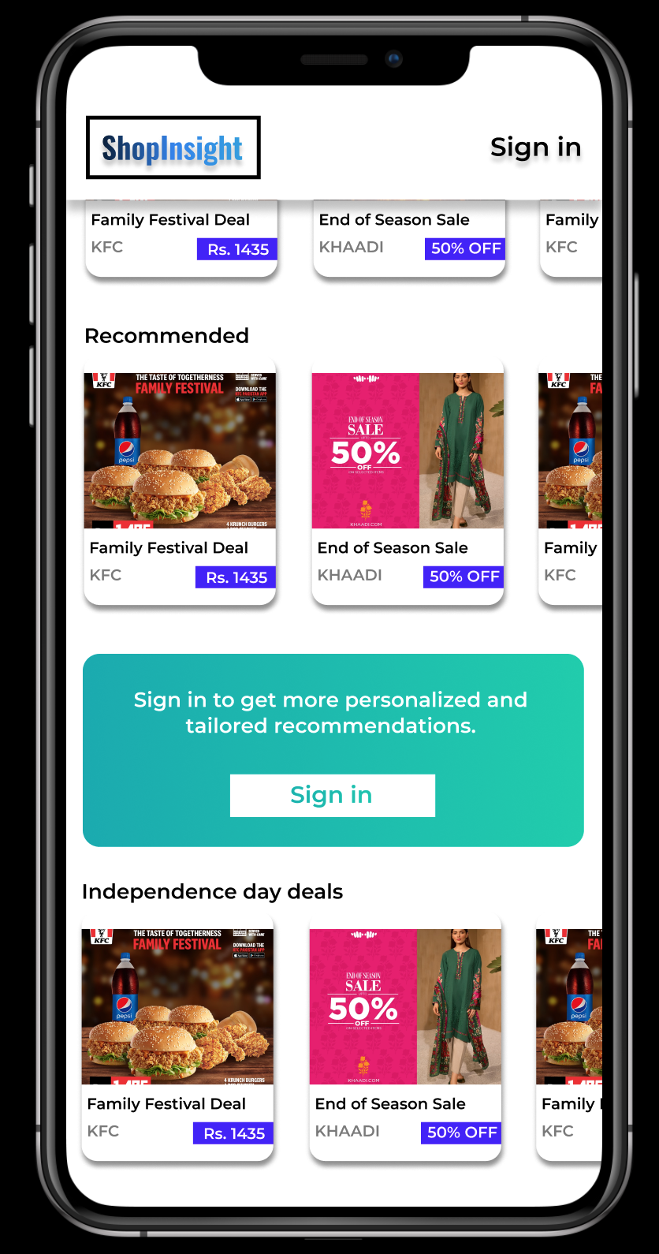

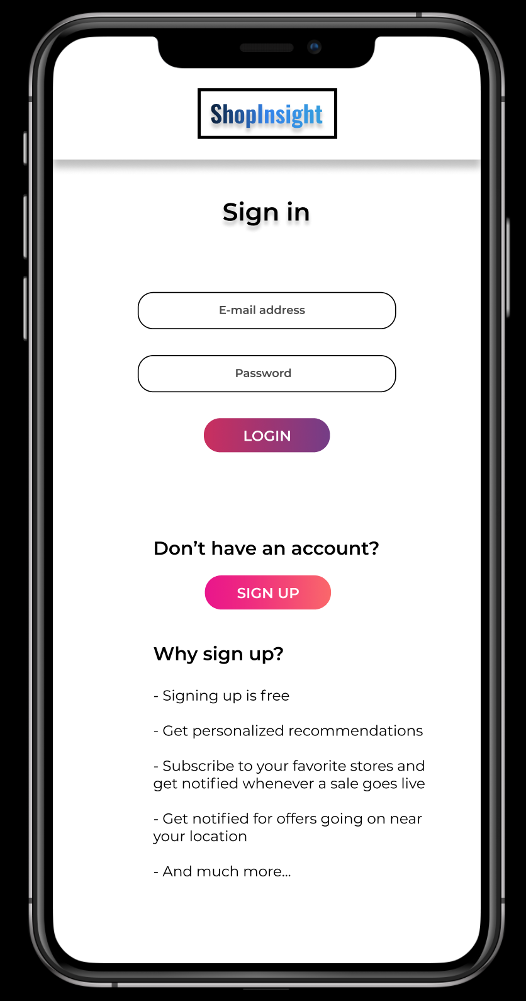

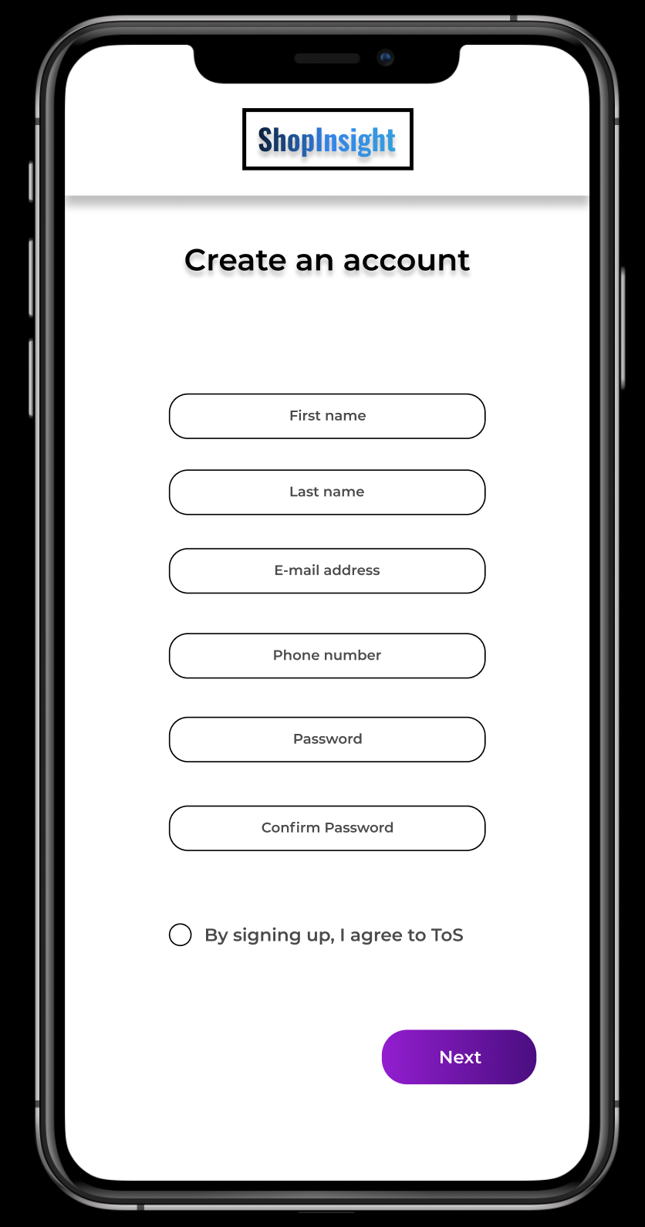

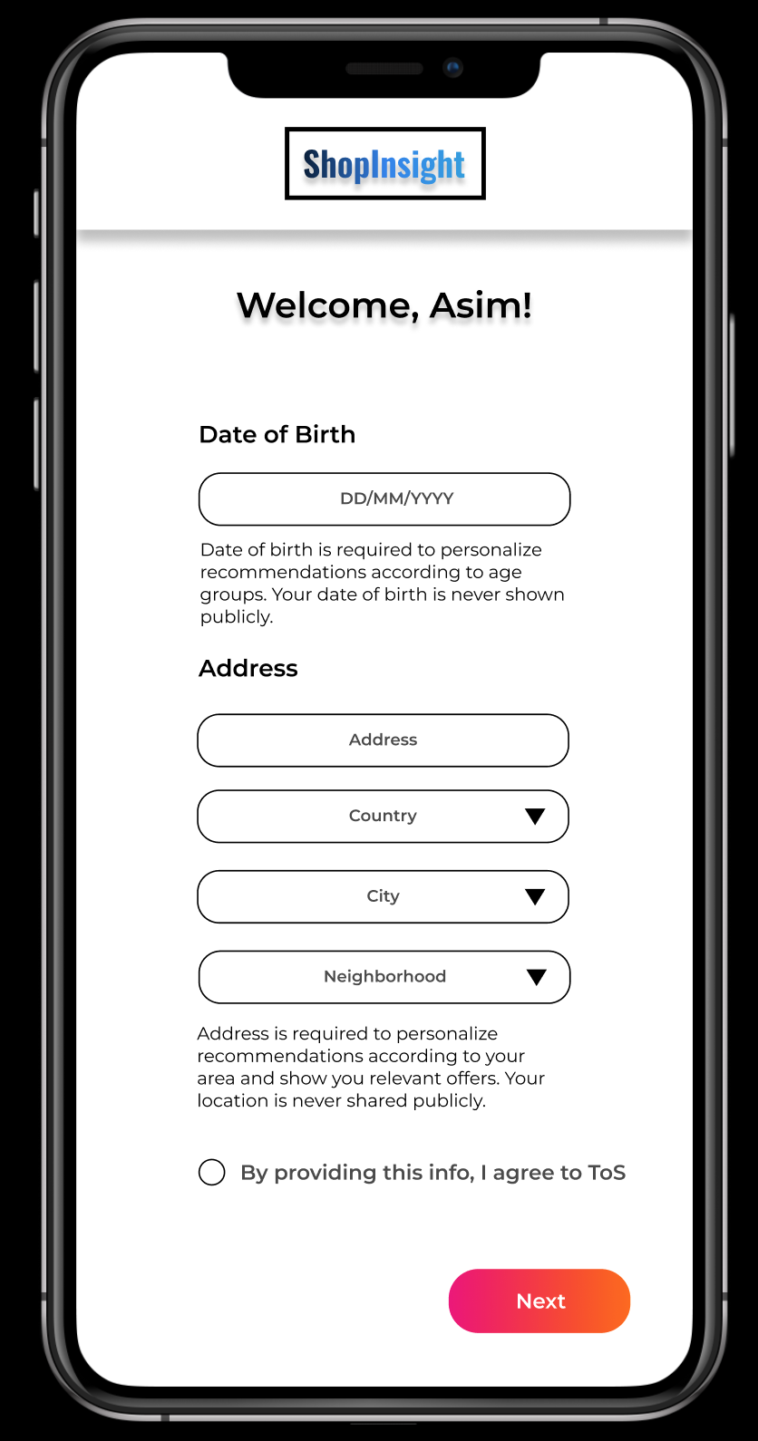

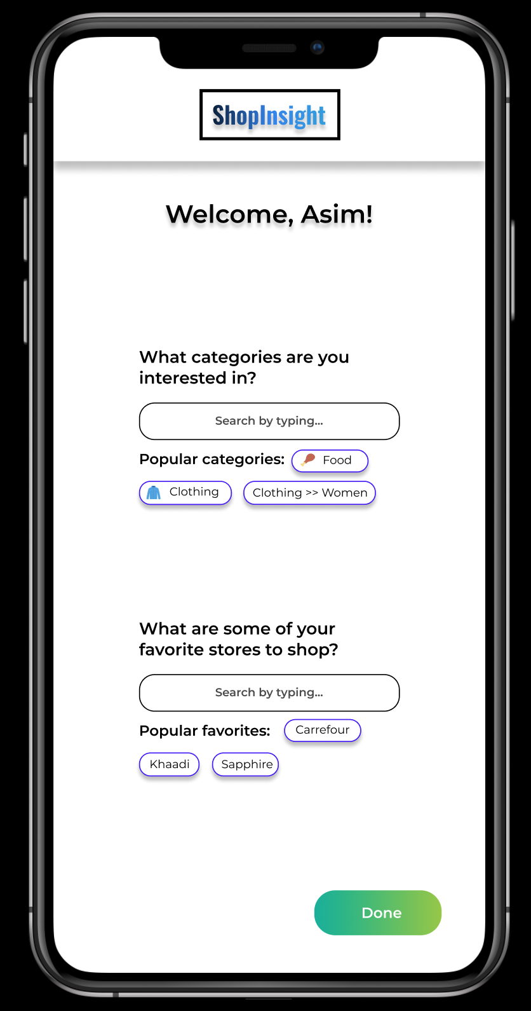

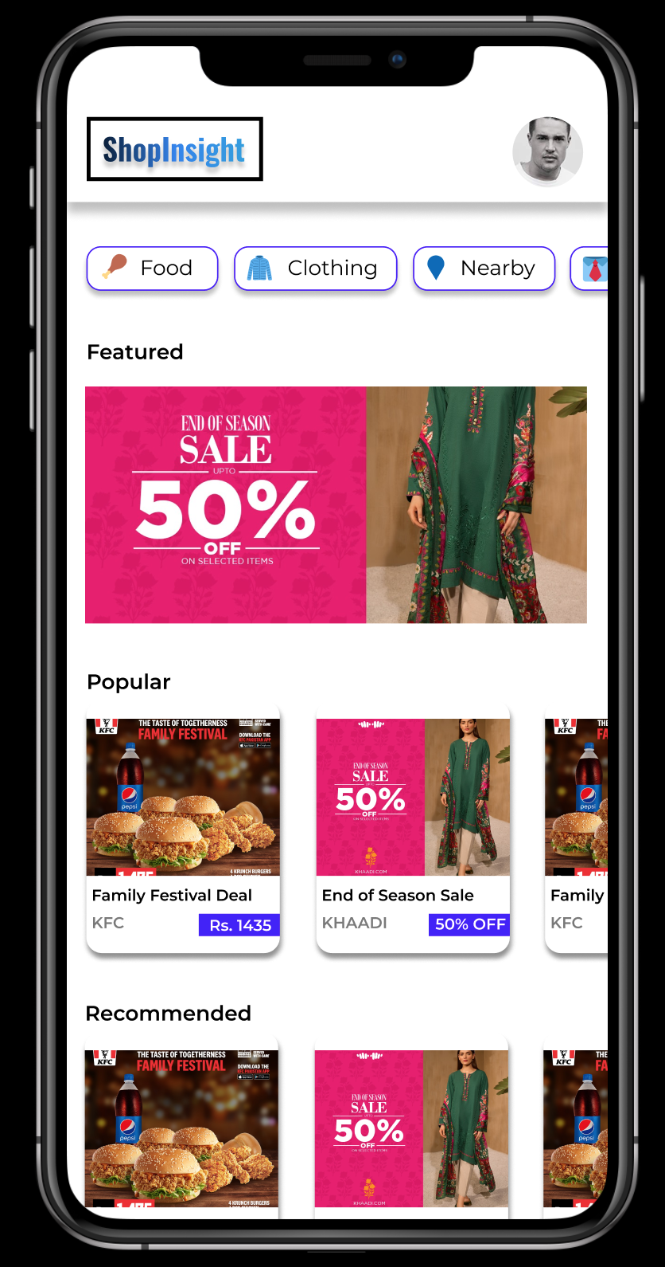

# Appendix I

* Plagiarism report (Pending)